

**Reserve Chardonnay 2013**

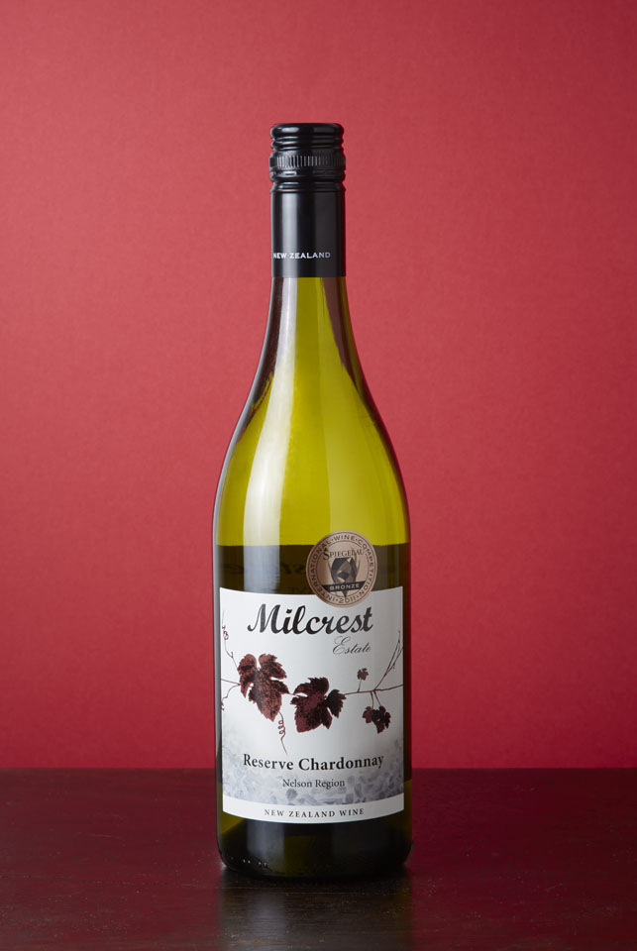***“Silver Medal NZIWS 2014”***          

**MILCREST ESTATE**

Milcrest Estate vineyard is located in Hope, Nelson at the foot of the Richmond Ranges and at the tip of New Zealand’s South Island.  High annual sunshine hours, a long ripening season, maritime climate and stony alluvial soils, combine to produce quality premium New Zealand wines from premium varietal grapes.

**2013 HARVEST:**

The 2013 Nelson vintage was an exceptional growing season for Nelson.  A fantastic flowering, a warm summer, but cooler autumn and a very settled harvest period, provided good conditions to make concentrated, quality wines across the varieties.  The season provided good consistent flowering during December 2012 resulting in lovely even ripe fruit characters. The Nelson Chardonnay fruit was picked incrementally at the peak of sugar flavour and ripeness on 24th March 2013, well before the autumn rains set in and in the very early morning when the grapes were cool, to maximize the potential of the wine.

**WINE ANALYSIS:**

Alcohol:                               14.5%

Residual Sugar                     Less than 3 g/l

Titratable Acidity:               8.8 g/l

Cases Produced:                  224

Brix at Harvest                     Average of 24.5 Brix

**VITICULTURE:**

Trellis System:                      VSP - 90% 2 cane, spur pruned

Leaf Plucked                        x2

Shoot thinning                      x1

Yield:                                   4 Tonne/ha

Planting density:                   1.8 x 2.6 m row spacing

Harvest date:                       24 March 2013

**WINE MAKERS COMMENTS:**

*This New Zealand, Nelson Region reserve Chardonnay was harvested from predominantly 10-15 year old vines. The chardonnay grapes were handpicked, de-stemmed. Barrel ferment in a combination of French and American Oak for 10 months. 60% malolactic fermentation. Initial frosts and a long, hot dry summer with perfect growing conditions, low yields with very little rain late in March, resulted in clean ripe high quality fruit arriving in the winery, producing intense classic chardonnay characters.*

**TASTING NOTES:** *The 2013 Nelson chardonnay grapes are sourced from the Nelson Region. The grapes were grown on Moutere Clays, This elegantly structured wine was aged in American Oak, producing a rich buttery example with aromas of white peach, melon & silky smooth vanilla on the finish. Drinking very well now but will continue to develop with careful cellaring over the next 6 years.*

**FOOD MATCH:** A perfect accompaniment to Nelson Scallops, Crayfish, prawns and is sensational with creamy pasta and chicken dishes.