Milcrest Estate Reserve Chardonnay 2017

5 Stars, 94 points Sam Kim Wine Orbit, Silver Medal NWWS 2017
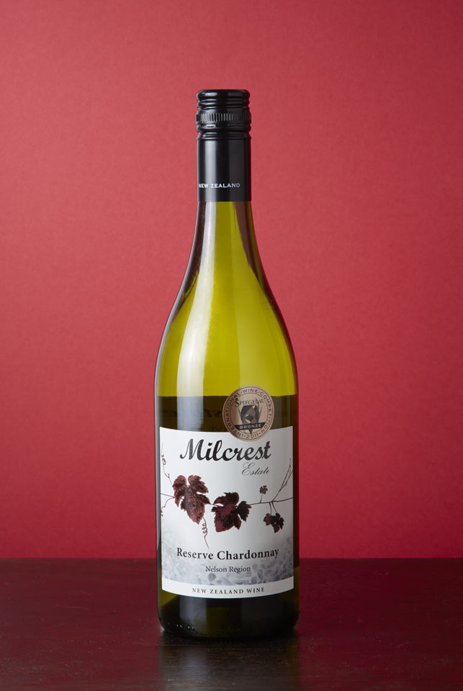
MILCREST ESTATE
Milcrest Estate vineyard is located in Hope, Nelson at the foot of the Richmond Ranges and at the tip of New Zealand’s South Island. High annual sunshine hours, a long ripening season, maritime climate and stony alluvial soils, combine to produce quality premium New Zealand wines from premium varietal grapes.
2017 HARVEST: The 2017 Nelson vintage was a challenging season for Nelson. A low yielding flowering due to strong winds, reducing crop yields by 25% but a long warm summer, cooler autumn and a very settled early harvest period until a cyclone dumped a large rainfall over two days. This resulted in a lot of crop loss in some parts of the region, but we were fortunate that we missed a lot of the rain and this resulted in a fabulous Chardonnay. The Nelson Chardonnay fruit was picked incrementally at the peak of sugar flavour and ripeness between 24th March and the end of March 2017, well before the autumn rains set in and in the very early morning when the grapes were cool, to maximize the potential of the wine.
WINE ANALYSIS:
Alcohol: 14%
Residual Sugar Less than 1 g/l
Titratable Acidity: 6.5 g/l
Cases Produced: 224
Brix at Harvest Average of 24.2 Brix

VITICULTURE:
Trellis System: VSP - 90% 2 cane, spur pruned
Leaf Plucked x2
Shoot thinning x1
Yield: 4 Tonne/ha
Planting density: 1.8 x 2.6 m row spacing
Harvest date: 25 March 2018

WINE MAKERS COMMENTS:
This New Zealand, Nelson Region reserve Chardonnay was harvested from predominantly 18-24 year old vines. The chardonnay grapes were handpicked, de-stemmed. Barrel fermented in a combination of French and American Oak for over 11 months. 96% French with the balance in American Oak. 60% malolactic fermentation. A challenging season with rain and wind but we managed to produce very good clean ripe high quality fruit, producing intense classic chardonnayCharacters .
TASTING NOTES: The 2017 Nelson chardonnay grapes are sourced from the Nelson Region. The grapes were grown on Moutere Clays, This elegantly structured wine was aged in French Oak with a small percentage of American Oak barriques producing a rich buttery example with aromas of ripe peach, melon & stonefruit with a silky smooth Crème Brule finish. Drinking very well now but will continue to develop over the next 6 years.
FOOD MATCH: A perfect accompaniment to Nelson scallops, salmon, prawns and is sensational with creamy pasta and chicken dishes.

